Hoisting:var can be defined later after assignment.very strange.(x=12)can be used and print the value of x .

Var:

Let:let maintains the declaring scope .

Rest: [1,2,…arr]

Spread:similar to rest.more flexible

For of:like for each loop in java.

For in:the values and keys of an object can be accessed by this.

For each: very different than for each in java.

Callback : this function maintains the sequence that when a function will be called with customized way. We also call one function a callback function if in the parameter functions are passed.

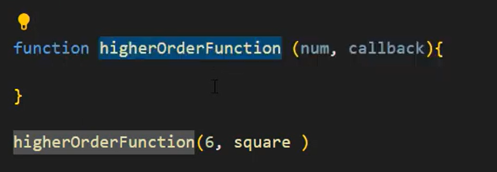

Asynchronous: If the methods are not invoked as per the sequence of how they are called serially in the code statements this situation is called a asynchronous function.

Promise: Promises are objects. When we create a promise object we pass two parameters, resolve function and reject function.we set conditions when the resolve function will be called and when reject function will be called. There is a thumb rule if resolve function will be called then there will be another function call. That function is “then”.our job is writing statements inside then funtions(defining).if reject function is called promise.catch(we also has the responsibility to define the function) function is called.

Asynchronous:

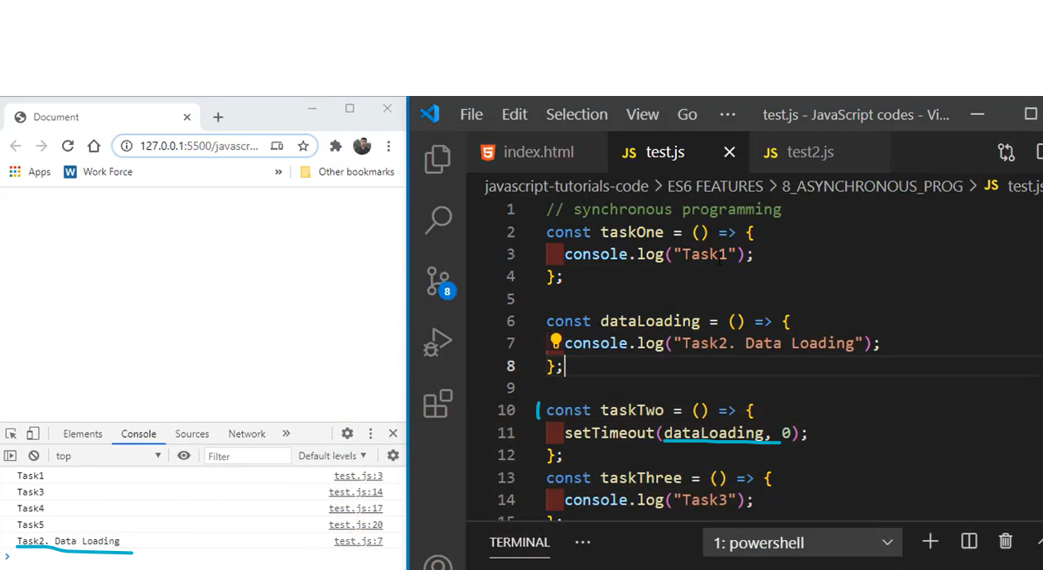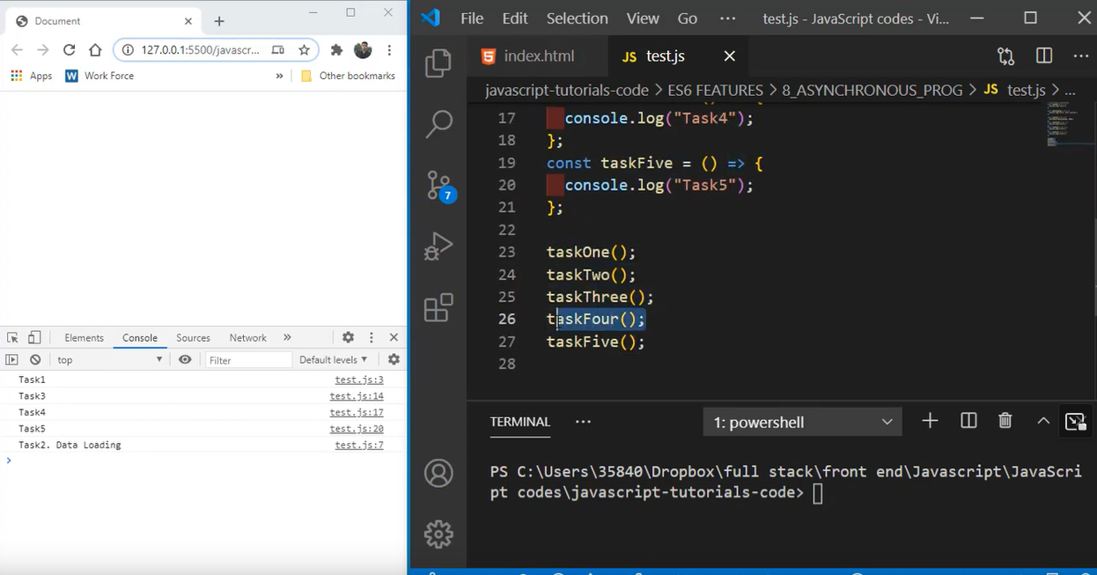

The top figure is where the functions has been defined and the latter figure shows how those methods were called.

If we look at the tasktwo method defination, there is method and a parameter(setTimeout(dataloading,0/2000)) , these together brings the tasktwo in the background while letting other methods to run . thought the method was called after task 1.

Await async: this function converts the async function into sync.that means previously we saw that task two went to background and was called at the last .But if we use async await in that case task two is first finished and then all other functions are called.

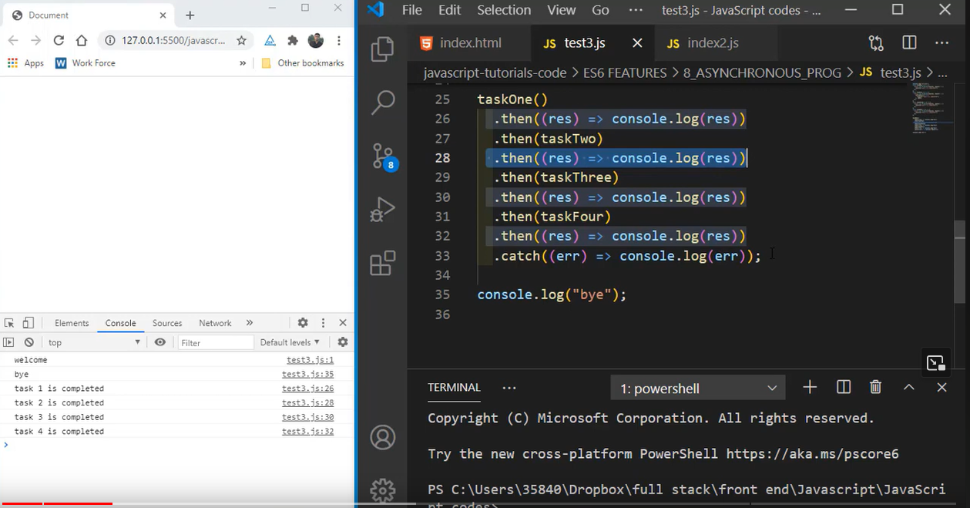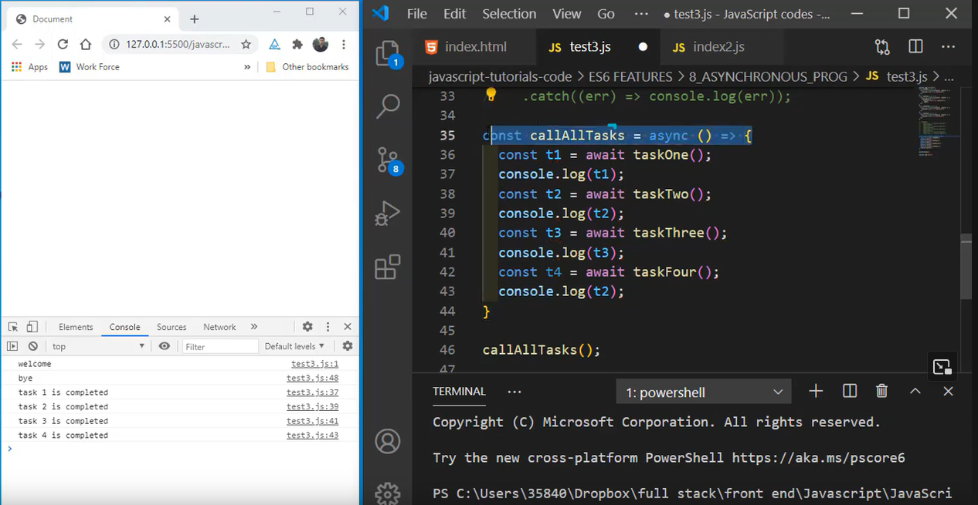

The left could be replaced by the right. As right is more improved version.

Return type in java vs javascript:

